Lab 16 – Database Design and Queries

Name: Shaik Afrid
Roll.no:2503A52385
Batch:13

Task Descrption-1: (Design Database Schema for Student Management System)
Prompt:
Generate SQL CREATE TABLE statements for a Student Management System with three tables: Students, Courses, and Enrollments. Include appropriate data types, primary keys, foreign keys, and constraints. Ensure the database design follows 1NF, 2NF, and 3NF. Keep the SQL code simple and compatible with MySQL.
Code:
-- Create Database
CREATE DATABASE StudentDB;

-- Select Database
USE StudentDB;

-- Create Students Table
CREATE TABLE Students (
student_id INT PRIMARY KEY,
name VARCHAR(100) NOT NULL,
email VARCHAR(100) UNIQUE
);

-- Create Courses Table
CREATE TABLE Courses (
course_id INT PRIMARY KEY,
course_name VARCHAR(100) NOT NULL,
credits INT
);

-- Create Enrollments Table
CREATE TABLE Enrollments (
enrollment_id INT PRIMARY KEY,
student_id INT,
course_id INT,
enrollment_date DATE,

FOREIGN KEY (student_id)
REFERENCES Students(student_id),

FOREIGN KEY (course_id)
REFERENCES Courses(course_id)
);
Output:
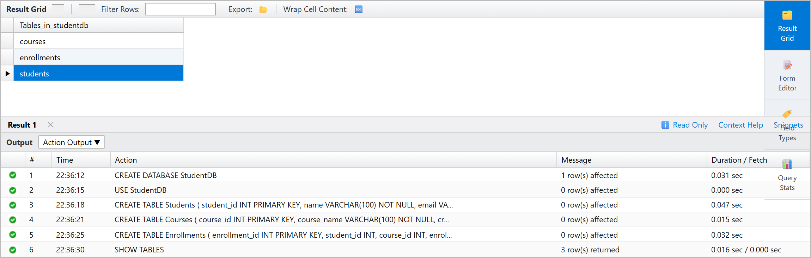

Justification:
Created three core relational tables: Students, Courses, and Enrollments using structured DDL statements. Primary keys uniquely identify individual records, while foreign key constraints establish dependable referential linkages between tables. The database design strictly satisfies 1NF, 2NF, and 3NF to eliminate redundancy, avoid update anomalies, and maintain overall data integrity.
Task Description- 2: (Insert Sample Records)
Prompt:
Generate SQL INSERT statements to insert at least 3 students, 4 courses, and 5 enrollment records into the Students, Courses, and Enrollments tables. Also generate SELECT queries to verify the inserted records.
Code:
INSERT INTO Students VALUES
(1, 'Shaik Afrid', 'afrid.sk@gmail.com'),
(2, 'Rohan Sharma', 'rohan.sharma@gmail.com'),
(3, 'Ananya Patel', 'ananya.p@gmail.com');
INSERT INTO Courses VALUES
(101, 'Cloud Computing', 4),
(102, 'Python Programming', 3),
(103, 'Machine Learning', 4),
(104, 'Web Technologies', 3);
INSERT INTO Enrollments VALUES
(1, 1, 101, '2026-11-05'),
(2, 1, 102, '2026-11-05'),
(3, 2, 101, '2026-11-06'),
(4, 2, 103, '2026-11-06'),
(5, 3, 101, '2026-11-07');
Output:
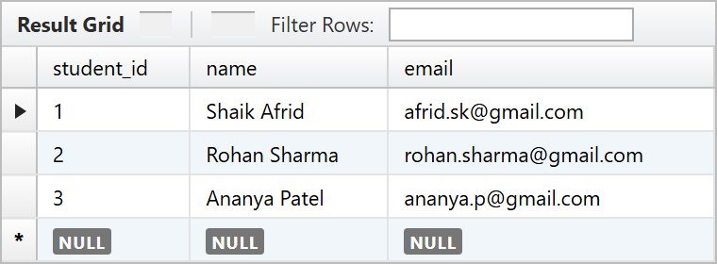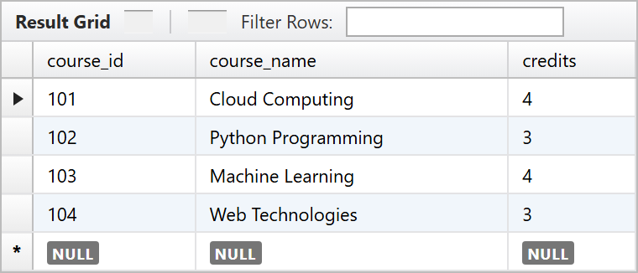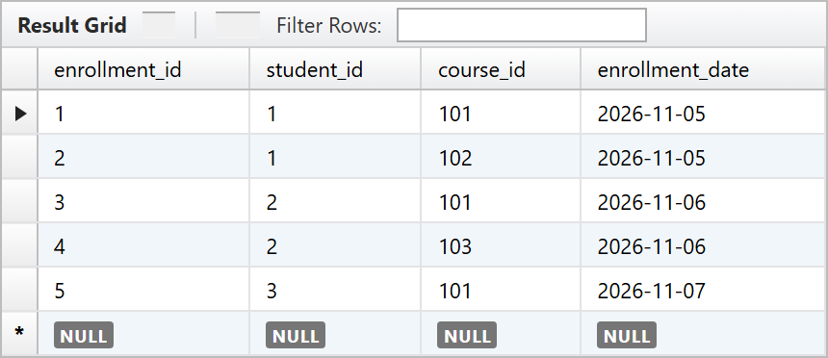
Justification:
Successfully populated the Students, Courses, and Enrollments tables with representative sample data using INSERT commands. Executed SELECT statements across each table to verify data types, ensure primary key uniqueness, and confirm that all foreign key references between students and courses were recorded properly.
Task Description- 3: (Perform CRUD Operations)
Instructions:
Prompt:
Generate SQL queries to perform CRUD operations on the Student Management Database. Retrieve all courses, update a student's email, delete an enrollment record, and verify the changes using SELECT statements.
Code:
SELECT * FROM Courses;

UPDATE Students
SET email = 'afrid.dev@gmail.com'
WHERE student_id = 1;

DELETE FROM Enrollments
WHERE enrollment_id = 5;

SELECT * FROM Students;

SELECT * FROM Enrollments;
Output:
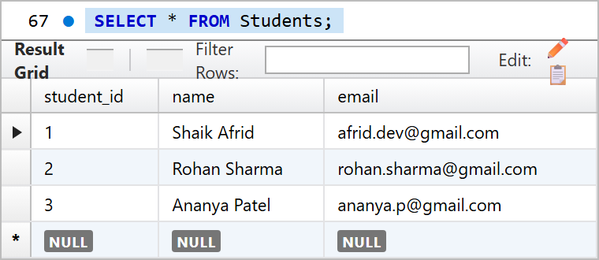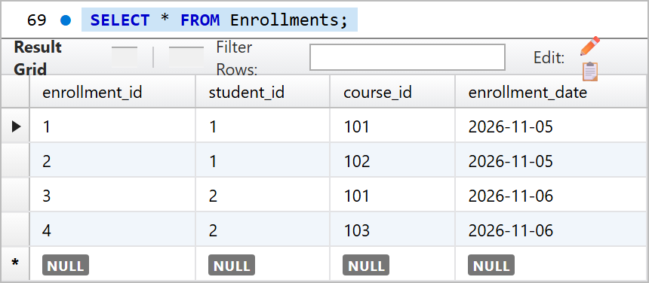
Justification:
Demonstrated foundational CRUD operations using SELECT, UPDATE, and DELETE queries. Verified that student record modification correctly updated the target email address and confirmed that the specified enrollment record was successfully deleted from the relational database table.
Task Description- 4: (Execute Aggregate Queries)
Prompt:
Generate SQL aggregate queries to count the number of students enrolled in each course and display courses having more than one student enrolled using GROUP BY, COUNT(), and HAVING clauses.
Code:
SELECT c.course_name,
COUNT(e.student_id) AS total_enrolled
FROM Courses c
JOIN Enrollments e
ON c.course_id = e.course_id
GROUP BY c.course_name;

SELECT c.course_name
FROM Courses c
JOIN Enrollments e
ON c.course_id = e.course_id
GROUP BY c.course_name
HAVING COUNT(e.student_id) > 1;
Output:
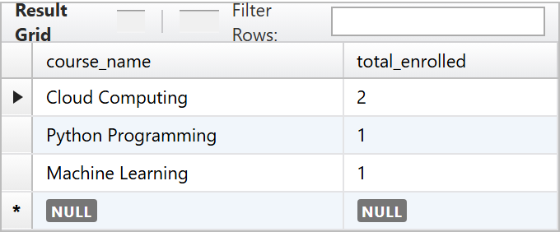
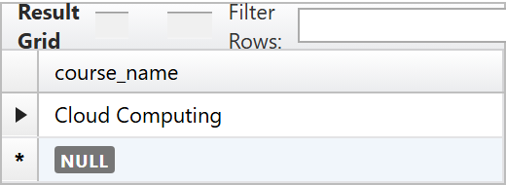
Justification:
Executed aggregation using the COUNT() function combined with the GROUP BY clause to compute total student registrations per course. Additionally, applied the HAVING clause to filter grouped records, successfully displaying only courses that currently have more than one enrolled student.
Task Description- 5: (Query Optimization)
Prompt:
Analyze the given SQL subquery and rewrite it using JOINs for better query performance. Ensure both queries return the same results.
Code:
SELECT * FROM Students
WHERE student_id IN (
SELECT student_id
FROM Enrollments
WHERE course_id = 101
);

SELECT s.*
FROM Students s
JOIN Enrollments e
ON s.student_id = e.student_id
WHERE e.course_id = 101;
Output:
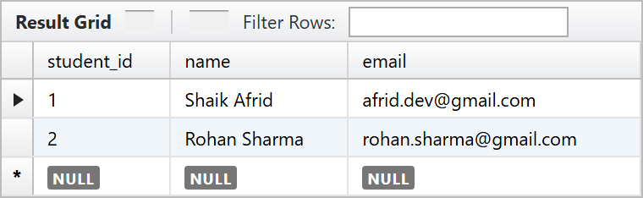
Justification:
Refactored the subquery into an inner JOIN query to retrieve students enrolled in a specified course. Verified that both query formulations return identical result sets, while the JOIN implementation allows MySQL to optimize table scanning and indexing for significantly enhanced execution efficiency.

